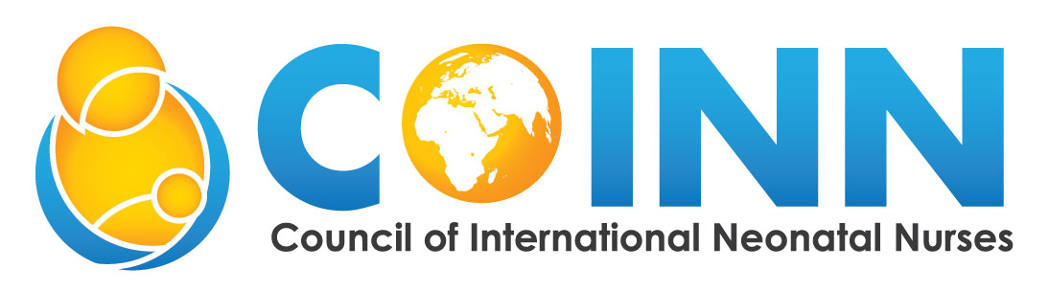

Post-Diploma Program in Neonatal Nursing (PDPINN)

PHILOSOPHY OF THE PROGRAM
The Council of International Neonatal Nurses, Inc. (COINN) is an international group that utilizes experts in neonatal nursing to offer education to nurses worldwide.
We Believe that:
- Registered nurses and midwives need to be trained in Neonatal Nursing content focusing on the small and sick newborn in the clinical setting to provide competent and safe care.
- Registered nurses and midwives need to be prepared in the expanding roles of nurses and advances in technology for effective participation in small and sick newborn care.

PURPOSE
The purpose of the course is to train nurses and midwives to:
1. Provide quality care to the small and sick newborn and their families.
2. Manage and supervise care of neonates at all three levels of care.
3. Teach nurses and midwives as well as family members in areas related to neonatal nursing.
4. Conduct research in area of neonatal nursing.

ADMISSION TERMS AND CONDITIONS
The students admitted to this course should:
1. Be a registered nurse or midwife
2. Have a minimum of two years neonatal experience
3. Nurses or midwives from other countries must provide proof of equivalent certification

DURATION
Course Duration 1 year

CERTIFICATION
1. Title – Post Basic Diploma in Neonatal Nursing
2. A diploma is awarded upon successful completion of the prescribed study program:
  - Prescribed courses in Neonatal Nursing
  - Prescribed clinical experience
  - Passed the prescribed examination
CLINICAL NURSING I
Course Description: This course is designed to develop an understanding of the principles of related biological and behavioral science in neonatal nursing
Unit | Theory
1 | Embryology
2 | Applied Anatomy and Physiology
3 | Pharmacology
4 | Neonatal Nursing 1
5 | Introduction to the Small and Sick Newborn
6 | Genetics
7 | Basic Resuscitation

CLINICAL NURSING II
Course Description: This course is designed to develop an understanding of the principles of nursing and management of the small and sick newborn.
Unit | Theory
1 | Management and Detection of Infection
2 | High Risk Newborn I
3 | High Risk Newborn II
4 | Care of Baby in Neonatal Unit and Beyond
5 | Quality Improvement & Research
6 | Leadership & Teaching Strategies
7 | Advanced Resuscitation

CLINICAL NURSING (TEACHING & SUPERVISION TO BE INTEGRATED)
HOUR DISTRIBUTION FOR CLINICAL EXPERIENCE
SR  NO | UNIT/DEPARTMENT | No. of Weeks
1 | Labor Unit | 2
2 | Postnatal Ward | 4
3 | Neonatal Unit | 4
 | Special Clinics (Pediatric Emergency Unit and others) | 1
4 | Discharge/Community Follow-up | 1
 | Total | 12

