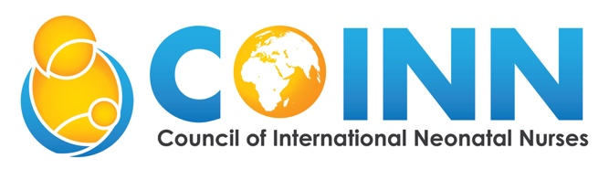
… Unifying neonatal nurses globally

Neonatal Nursing Externship/Orientation Program

This course is created for new and current nurses/midwives working in neonatal units. The course offers 12 weeks of didactic lectures. The didactic component includes lectures on neonatal nursing, pregnancy, labor, and birth; essential care of the newborn, feeding the term infant; failure to breath, organization of the neonatal unit; introduction to the small and sick newborn and feeding the small and sick infant; pharmacology, infection; respiratory and hematology; neurology and advanced resuscitation; genetics and surgery; cardiac and eye, ear and throat; neurodevelopment and discharge; ethics, quality improvement (QI )and research then leadership and teaching other. There is an expectation that as the students proceed through the program that they are being precepted in a neonatal unit.

Week | Theory
1 | Preconception, Pregnancy, Labor & Delivery and Neonatal Nursing
2 | Essential Care of Newborn and Feeding the Well Newborn
3 | Failure to Breath and Organization of Neonatal Unit
4 | Introduction to the Small and Sick and Feeding the Small and Sick Newborn
5 | Pharmacology and Management of Infection
6 | Respiratory and Hematology
7 | Neurology and Advanced Resuscitation
8 | Genetics and Surgery
9 | Cardiac, Eye, Ear, Mouth and Nose/Throat
10 | Neurodevelopment, Testing, Discharge, Referral and Follow-up
11 | Ethics, Professionalism, Quality Improvement, and Research
12 | Leadership and Education

